WORKSHEET - CUTTING THREADS
The Basics NAME: _______________

Find and record the TAP DRILL SIZE for each of the following TAP SIZES:

TAPS  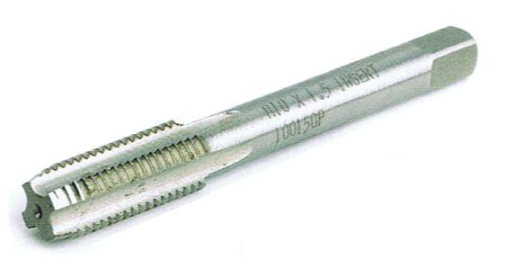 | - Cuts _______________ threads  - Requires a _______________ size hole
TAP DRILL CHART  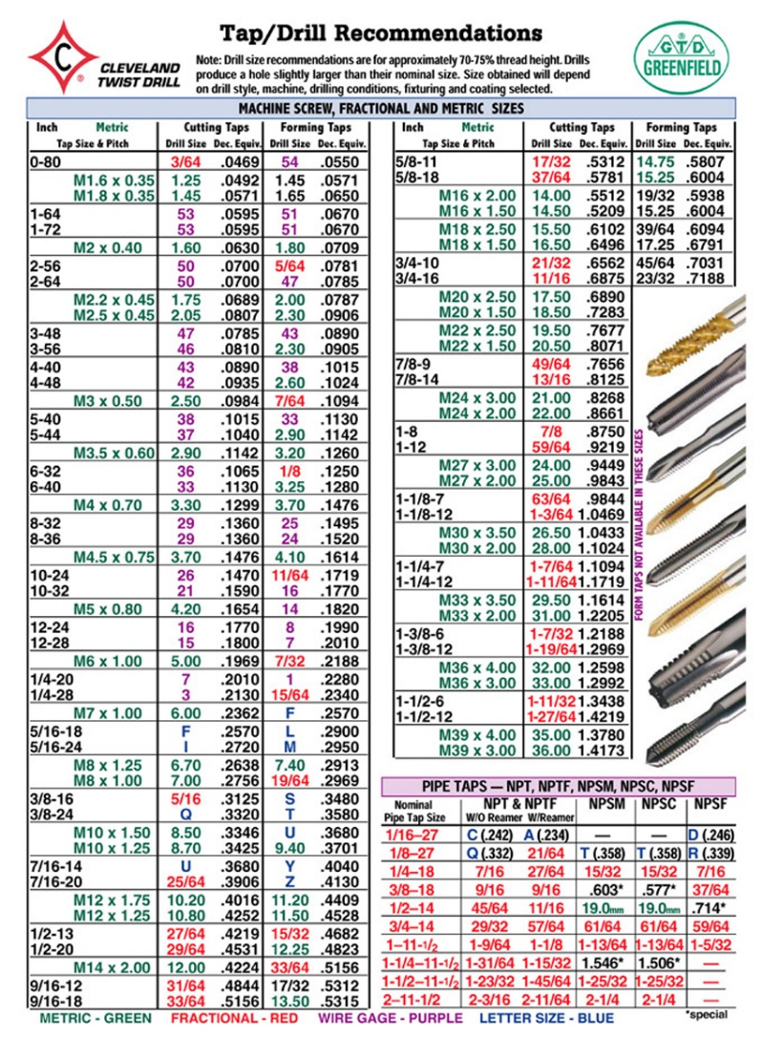 | - Tells you which _______________ _______________ to use
DIES  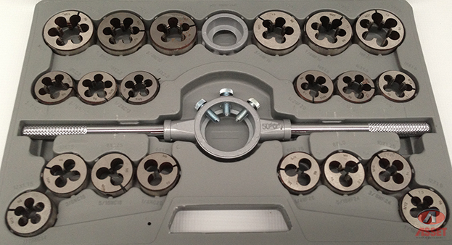 | - Cuts _______________ threads  - For a specific sized _______________ of material
TAPPING OIL  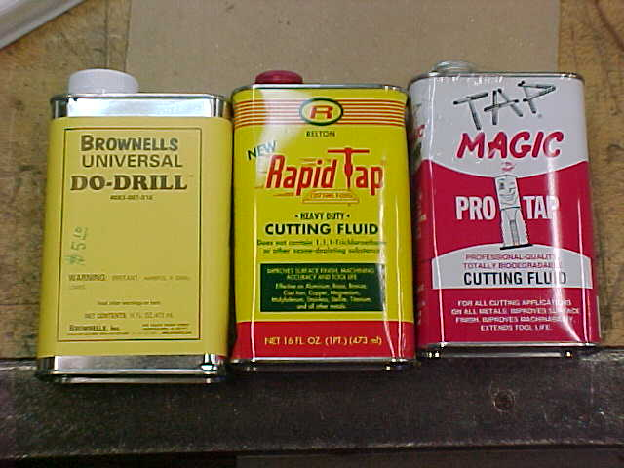 | - Required for _______________ threads,  long _______________ _______________,  and less _______________
VIDEO on CUTTING THREADS (NO NOTES)

Find and record the TAP DRILL SIZE for each of the following TAP SIZES:
1/4-28
5/16-UNC
1/2-13
5/8-UNF
1-8
M6-1.00
M8-1.25
M10-1.50
M12-1.75
M14-2.00

